

GHANA ROBOTICS COMPETITION 2026
ENGINEERS LEAGUE
GAME MANUAL

The Green Recovery Mission
Operation Green Recovery

For 18+ (University & Professional)
FULLY AUTONOMOUS • 1v1 • 3 Minutes

Theme: AI & Robotics for Sustainable Africa
Field: 70 × 70 inches (1780 × 1780mm)

Version 1.0 — April 2026
Prepared by Firefly IO — grc@fireflyio.com

1. Competition Overview

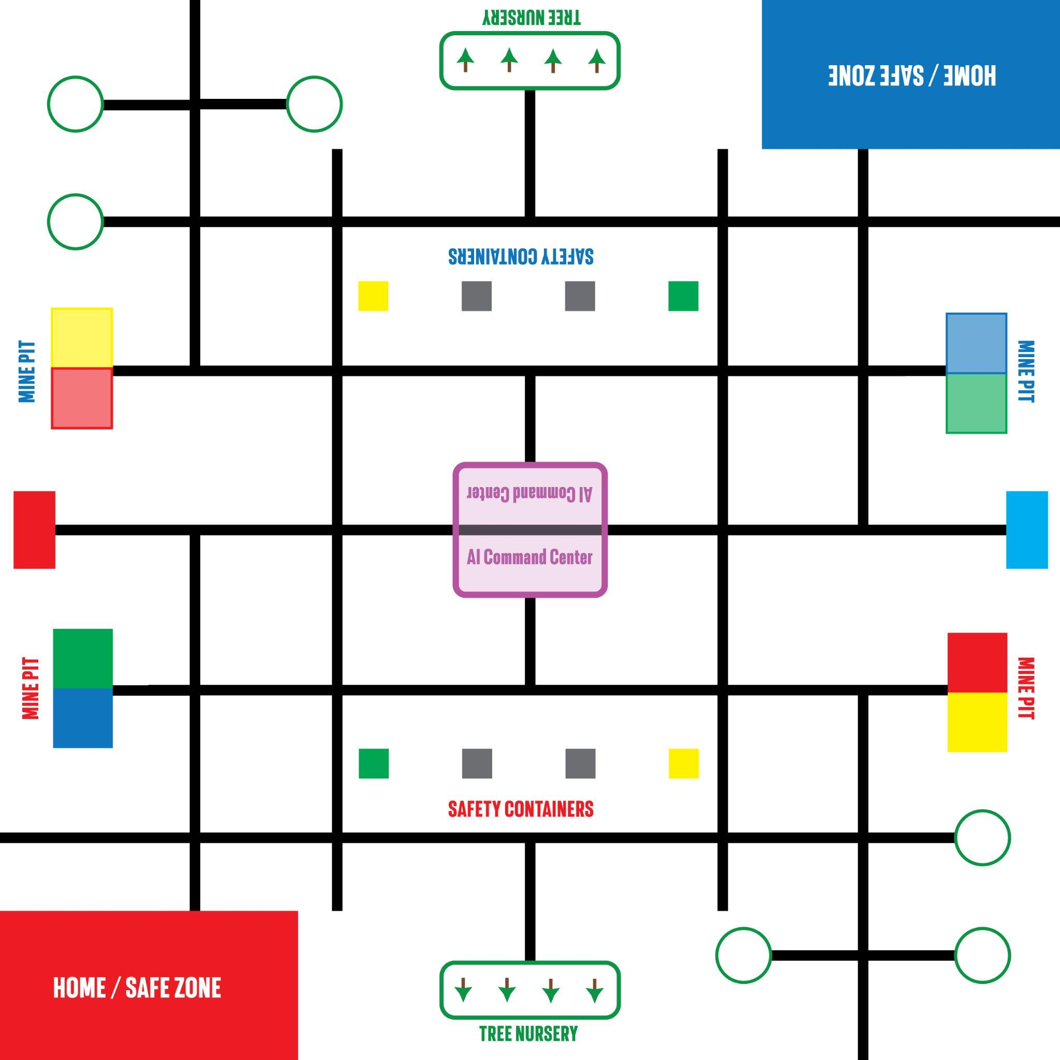

1.1 What Makes Engineers Different
The Engineers League is the ultimate test of autonomous robotics. Unlike Techs and Stars, there is NO manual control period — the robot operates entirely from pre-programmed code for the full 3 minutes. There is also NO alliance play — it is 1 robot versus 1 robot, head to head. This is pure engineering.
No remote control. No alliance partner. No second chances. Just your code, your robot, and 3 minutes to prove it works.

1.2 Match Format
Parameter | Value
Match Duration | 3 minutes total
Control Mode | FULLY AUTONOMOUS (entire match)
Manual Control | NONE
Format | 1v1 (Red vs Blue, 1 robot per side)
Alliance Play | NONE
Field Size | 70 × 70 inches (1780 × 1780mm)
Field Layout | 180° rotational symmetry (Red vs Blue)
Robot Platform | XploreBot
Robot Start Size | 30 × 30 × 30 cm max

1.3 Field Layout
The field is divided into two halves with 180° rotational symmetry. Red Home Base is at the bottom-left corner, Blue Home Base is at the top-right corner. Each side has identical mission elements mirrored. The AI Command Center sits at the center of the field, shared between both sides.
The field uses a grid navigation system with black lines and green circle intersection markers. The robot navigates by following lines and counting intersections.

1.4 Challenge Narrative
Illegal mining has devastated Ghana’s landscape. Your autonomous robot must independently navigate the recovery site, secure dangerous mine pits with color-coded safety containers, replant deforested areas with tree seedlings, and activate the AI Command Center to coordinate the full recovery operation — all without any human intervention during the match.

2. Missions
The Engineers League features 4 missions. All missions must be completed autonomously — there is no manual period.

M1. Mine Pit Safety
Illegal mining has left dangerous open pits. The robot picks up color-coded safety containers from a track line and delivers each to its matching colored pit to secure it.
How It Works
Four mine pits (color-coded) are located at the side edge of the robot’s half. Four matching safety containers are placed along a separate track line. The robot must navigate to the containers, identify each by color, pick one up, then navigate to the matching pit and place it inside. Placing a container in the wrong pit incurs a penalty.
Scoring
Action | Points
Correct container in matching pit | 40
Wrong color container in pit | -15 penalty
All 4 pits correctly secured | +30 completion bonus
Field Elements
Element | Specification
Mine Pits | 4 recessed zones at side edge (color-coded: R/B/G/Y)
Safety Containers | 4 cubes (50mm), color-matched, spaced along track line
• Color identification must be done autonomously — no human input.

M2. Reforestation
Degraded mining land must be replanted. The robot collects tree seedlings from the Tree Nursery and plants them in designated planting areas.
How It Works
Three tree seedlings are arranged in a line at the Tree Nursery zone on the robot’s side. Planting depots are located at various positions. The robot picks up trees and navigates to plant them in the depot holes.
Scoring
Action | Points
Tree planted in depot | 30
All 3 trees planted | +25 completion bonus
Field Elements
Element | Specification
Tree Seedlings | 3 per side, arranged in line at Tree Nursery
Tree Nursery | Marked zone at edge of robot’s half
Planting Depots | Planting holes at designated positions
• Trees must be placed upright in the hole to score.
• Robots may carry only 1 tree at a time.

M3. AI Command Center
An AI-powered command center sits at the center of the field. The robot must deliver a Data Module, press the Broadcast Button, and raise the Antenna to bring the system online.
How It Works
The AI Command Center is the central structure shared between both sides. It has an Upper Slot (120mm height, harder) and a Lower Slot (40mm lower, easier). Each side has one Data Module that starts at or near the Home Base. The robot must pick up its Data Module, navigate to the center, insert it into a slot, press the Broadcast Button, and raise the Antenna.
Scoring
Action | Standard | After Accelerator
Data Module to Upper Slot | 30 | 60
Data Module to Lower Slot | 20 | 40
Broadcast Button pressed | 15 | 15
Antenna raised to vertical | 20 | 20
Field Elements
Element | Specification
Command Center | Central structure, shared between both sides
Upper Slot | 60 × 60mm at 120mm height
Lower Slot | 60 × 60mm at 40mm height
Antenna | Hinged arm, starts horizontal
Broadcast Button | Spring-loaded, on platform
Data Module | 50mm cube, 1 per side, starts at Home Base
• Data Module starts at Home Base.
• Broadcast Button can only be pressed after Data Module is inserted.
• Antenna must be within 10° of vertical to score.
• Since both robots are autonomous, there is no “race bonus” — both robots can independently complete the sequence.

M4. Resilience Accelerator
Each side has its own Resilience Accelerator. When activated, it doubles the AI Command Center scoring for that robot.
Scoring
Action | Points
Accelerator activated | 0 (enables 2× M3 scoring)
Rules
• Each side has its own Accelerator — not shared.
• Can be activated at any point during the 3-minute match (no time window restriction).
• Robot must press and hold for approximately 2 seconds.
• Once activated, doubles all subsequent AI Command Center scoring.
Strategic decision: the robot’s code must decide whether to spend time activating the Accelerator before going to the Command Center, or skip it and score directly. This decision must be programmed in advance — there is no human to make the call during the match.

3. Game Features

3.1 Precision Tokens
Each team starts with 7 Precision Tokens worth 15 points each (105 total). Since the match is fully autonomous, tokens should only be lost if a team member touches their robot during the match (which should not happen). However, tokens may also be removed if:
• A team member reaches onto the field during the match.
• A team member interferes with the field or opponent’s robot.
• A team member attempts to communicate with or signal their robot.
In a fully autonomous match, keeping all 7 tokens should be the default. Losing even one means a serious rules violation occurred.

3.2 Innovation Point
The Innovation Point is automatically tracked for the Engineers League. Since the entire match is autonomous, any robot that successfully delivers the Data Module to the Upper Slot of the AI Command Center earns the Innovation Point. This serves as the first tiebreaker in rankings.

3.3 Emergency Evacuation (Endgame)
When 30 seconds remain, an audible signal sounds. If the robot’s code is programmed to respond to this signal (via a timer or sound sensor), it can navigate back to the Home Base for evacuation points.
Action | Points
Robot in Home Base at match end | 10
Since there is no alliance partner, there is no non-linear bonus. A single robot returning home earns 10 points.

3.4 Surprise Rule
A single rule modification is revealed at the Opening Ceremony. Teams get 45 minutes of practice time to adapt and reprogram before matches begin.
This is the ultimate test of adaptability. Teams must modify their autonomous code under pressure — no remote control fallback.

4. General Rules

4.1 Robot Specifications
Requirement | Specification
Platform | XploreBot (Firefly IO)
Maximum Starting Size | 30 × 30 × 30 cm
Programming | Xplore IDE
Navigation | Line-following sensors (no encoders)
Autonomous Method | Follow lines + count intersections
Manual Control | NOT ALLOWED at any point during the match

4.2 Match Phases
1. Setup (30 seconds): Team places robot in Home Base. Final code upload must be completed before setup ends.
2. Match Start: Referee signals start. Robot begins executing pre-programmed code.
3. Full Autonomous (3 minutes): Robot operates entirely from code. No human interaction of any kind. No touching, no signaling, no remote control.
4. Endgame Signal (at 2:30): Audible signal sounds with 30 seconds remaining. Robot may respond if programmed to.
5. Match End: Referee signals end. Robot must stop. Scoring assessed.

4.3 Autonomous Rules
• The entire match is autonomous. There is NO manual control period.
• Once the match starts, no team member may touch the robot, the field, or any field element.
• No remote control devices, hand signals, voice commands, or any form of communication with the robot is allowed.
• The robot’s code must handle all navigation, object detection, pickup, delivery, and mechanism activation independently.
• If the robot malfunctions, the team may NOT intervene. The robot continues (or stops) on its own.

4.4 Penalties
• Touching robot during match: lose 1 Precision Token + 10-point penalty
• Signaling or communicating with robot: lose 1 Precision Token + 10-point penalty
• Interfering with opponent’s robot or field elements: disqualification
• Wrong color container in pit: -15 points
• Robot exceeds starting size: must resize or forfeit

4.5 Tiebreaker Order
1. Innovation Point (Data Module to Upper Slot)
2. Higher Total Score
3. More Missions Completed
4. Fewer Penalties
5. Random Draw

5. Tournament Format

5.1 Preliminary Matches (Ranking Stage)
All preliminary matches are ranking-based. Each team plays 3 preliminary 1v1 matches. Scores from all 3 matches are added together. Teams are ranked by total combined score. No win points — only total score.

5.2 Qualification to Knockout
Top teams qualify based on league size: 32+ teams = top 32; 17–32 = top 16; 9–16 = top 8.

5.3 Knockout Stage (Direct Elimination)
Win and advance. Lose and you are out. Each match is independent.
No alliance play in Engineers. It is 1v1. Your score is only compared to your direct opponent.

5.4 Knockout Tiebreaker
1. Fastest Task Completion: Team that completed a designated task first wins
2. Replay: If still tied, a 2-minute replay match is conducted

6. Match Procedures

6.1 Robot Malfunction
• Non-functional before match: team reports, match proceeds. Opponent plays normally.
• Malfunction during match: no intervention allowed. Points before malfunction count.

6.2 No-Show
• 2-minute grace period. After: no-show = 0 points, opponent wins by default. 3+ no-shows = disqualification.

6.3 Field Malfunction
• Referee stops match. <1 min: full replay. >1 min: continue from stoppage. 5 min reset.

7. Coaches / Adult Rules
When in doubt: “Student Led, Student Success”
• Focus on Learning Over Winning: Emphasize learning and growth.
• Respect Student Centeredness: Students design, build, program, troubleshoot.
• Provide Guidance, Not Answers: Leading questions, not direct solutions.
• Maintain a Positive Environment: Supportive. No negative comments.
• Encourage Student Communication: Students talk to judges and referees.
• Stay Behind the Scenes: Adults in background during matches.
• Respect All Participants: Courtesy and respect for everyone.

8. Complete Scoring Summary
All points are earned autonomously. There is no manual scoring multiplier — all actions are scored at the autonomous rate.

Action | Points
— M1: MINE PIT SAFETY —
Correct container in matching pit | 40 each
All 4 pits secured | +30
Wrong color penalty | -15
— M2: REFORESTATION —
Tree planted in depot | 30 each
All 4 trees planted | +25
— M3: AI COMMAND CENTER —
Data Module to Upper Slot | 30 (60 after Accelerator)
Data Module to Lower Slot | 20 (40 after Accelerator)
Broadcast Button pressed | 15
Antenna raised | 20
— M4: RESILIENCE ACCELERATOR —
Accelerator activated | 0 (enables 2× M3)
— ENDGAME —
Robot in Home Base at match end | 10
— PRECISION TOKENS —
Each token remaining (7 max) | 15
Maximum token bonus | 105

Maximum theoretical score per robot: ~470 points
A perfect run: all 4 pits correct (190), all 4 trees planted (145), Accelerator + full Command Center (115), evacuation (10), all tokens (105) = 565 points.

6. Why Engineers League Matters
The Engineers League represents the pinnacle of GRC competition. While Techs and Stars test remote control skills alongside basic autonomous programming, Engineers tests something far more demanding: can your robot think for itself?
Every decision — which mission to attempt first, which route to take, how to handle unexpected obstacles, whether to activate the Accelerator before going to the Command Center, when to start heading home for evacuation — must be coded in advance. There is no human backup.
This is the kind of challenge that prepares university students for careers in robotics, automation, AI, and systems engineering. Companies building autonomous vehicles, warehouse robots, agricultural drones, and industrial automation need engineers who can think this way.
The Engineers League is not just a competition. It is a proving ground for Ghana’s next generation of automation engineers.

END OF ENGINEERS LEAGUE GAME MANUAL v1.0
Ghana Robotics Competition 2026 — Powered by Firefly IO
grc@fireflyio.com — +233 54 452 5401

