

GHANA ROBOTICS COMPETITION 2026
STARS LEAGUE
GAME MANUAL

The Green Recovery Mission
Operation Green Recovery

10 Missions • 4-Quadrant Field • 2v2 Alliance Play
2 Minutes Autonomous + 1 Minute Manual

Theme: AI & Robotics for Sustainable Africa
Field: 96 × 96 inches (2438 × 2438mm)

Version 3.0 — April 2026
Prepared by Firefly IO — grc@fireflyio.com

1. Competition Overview

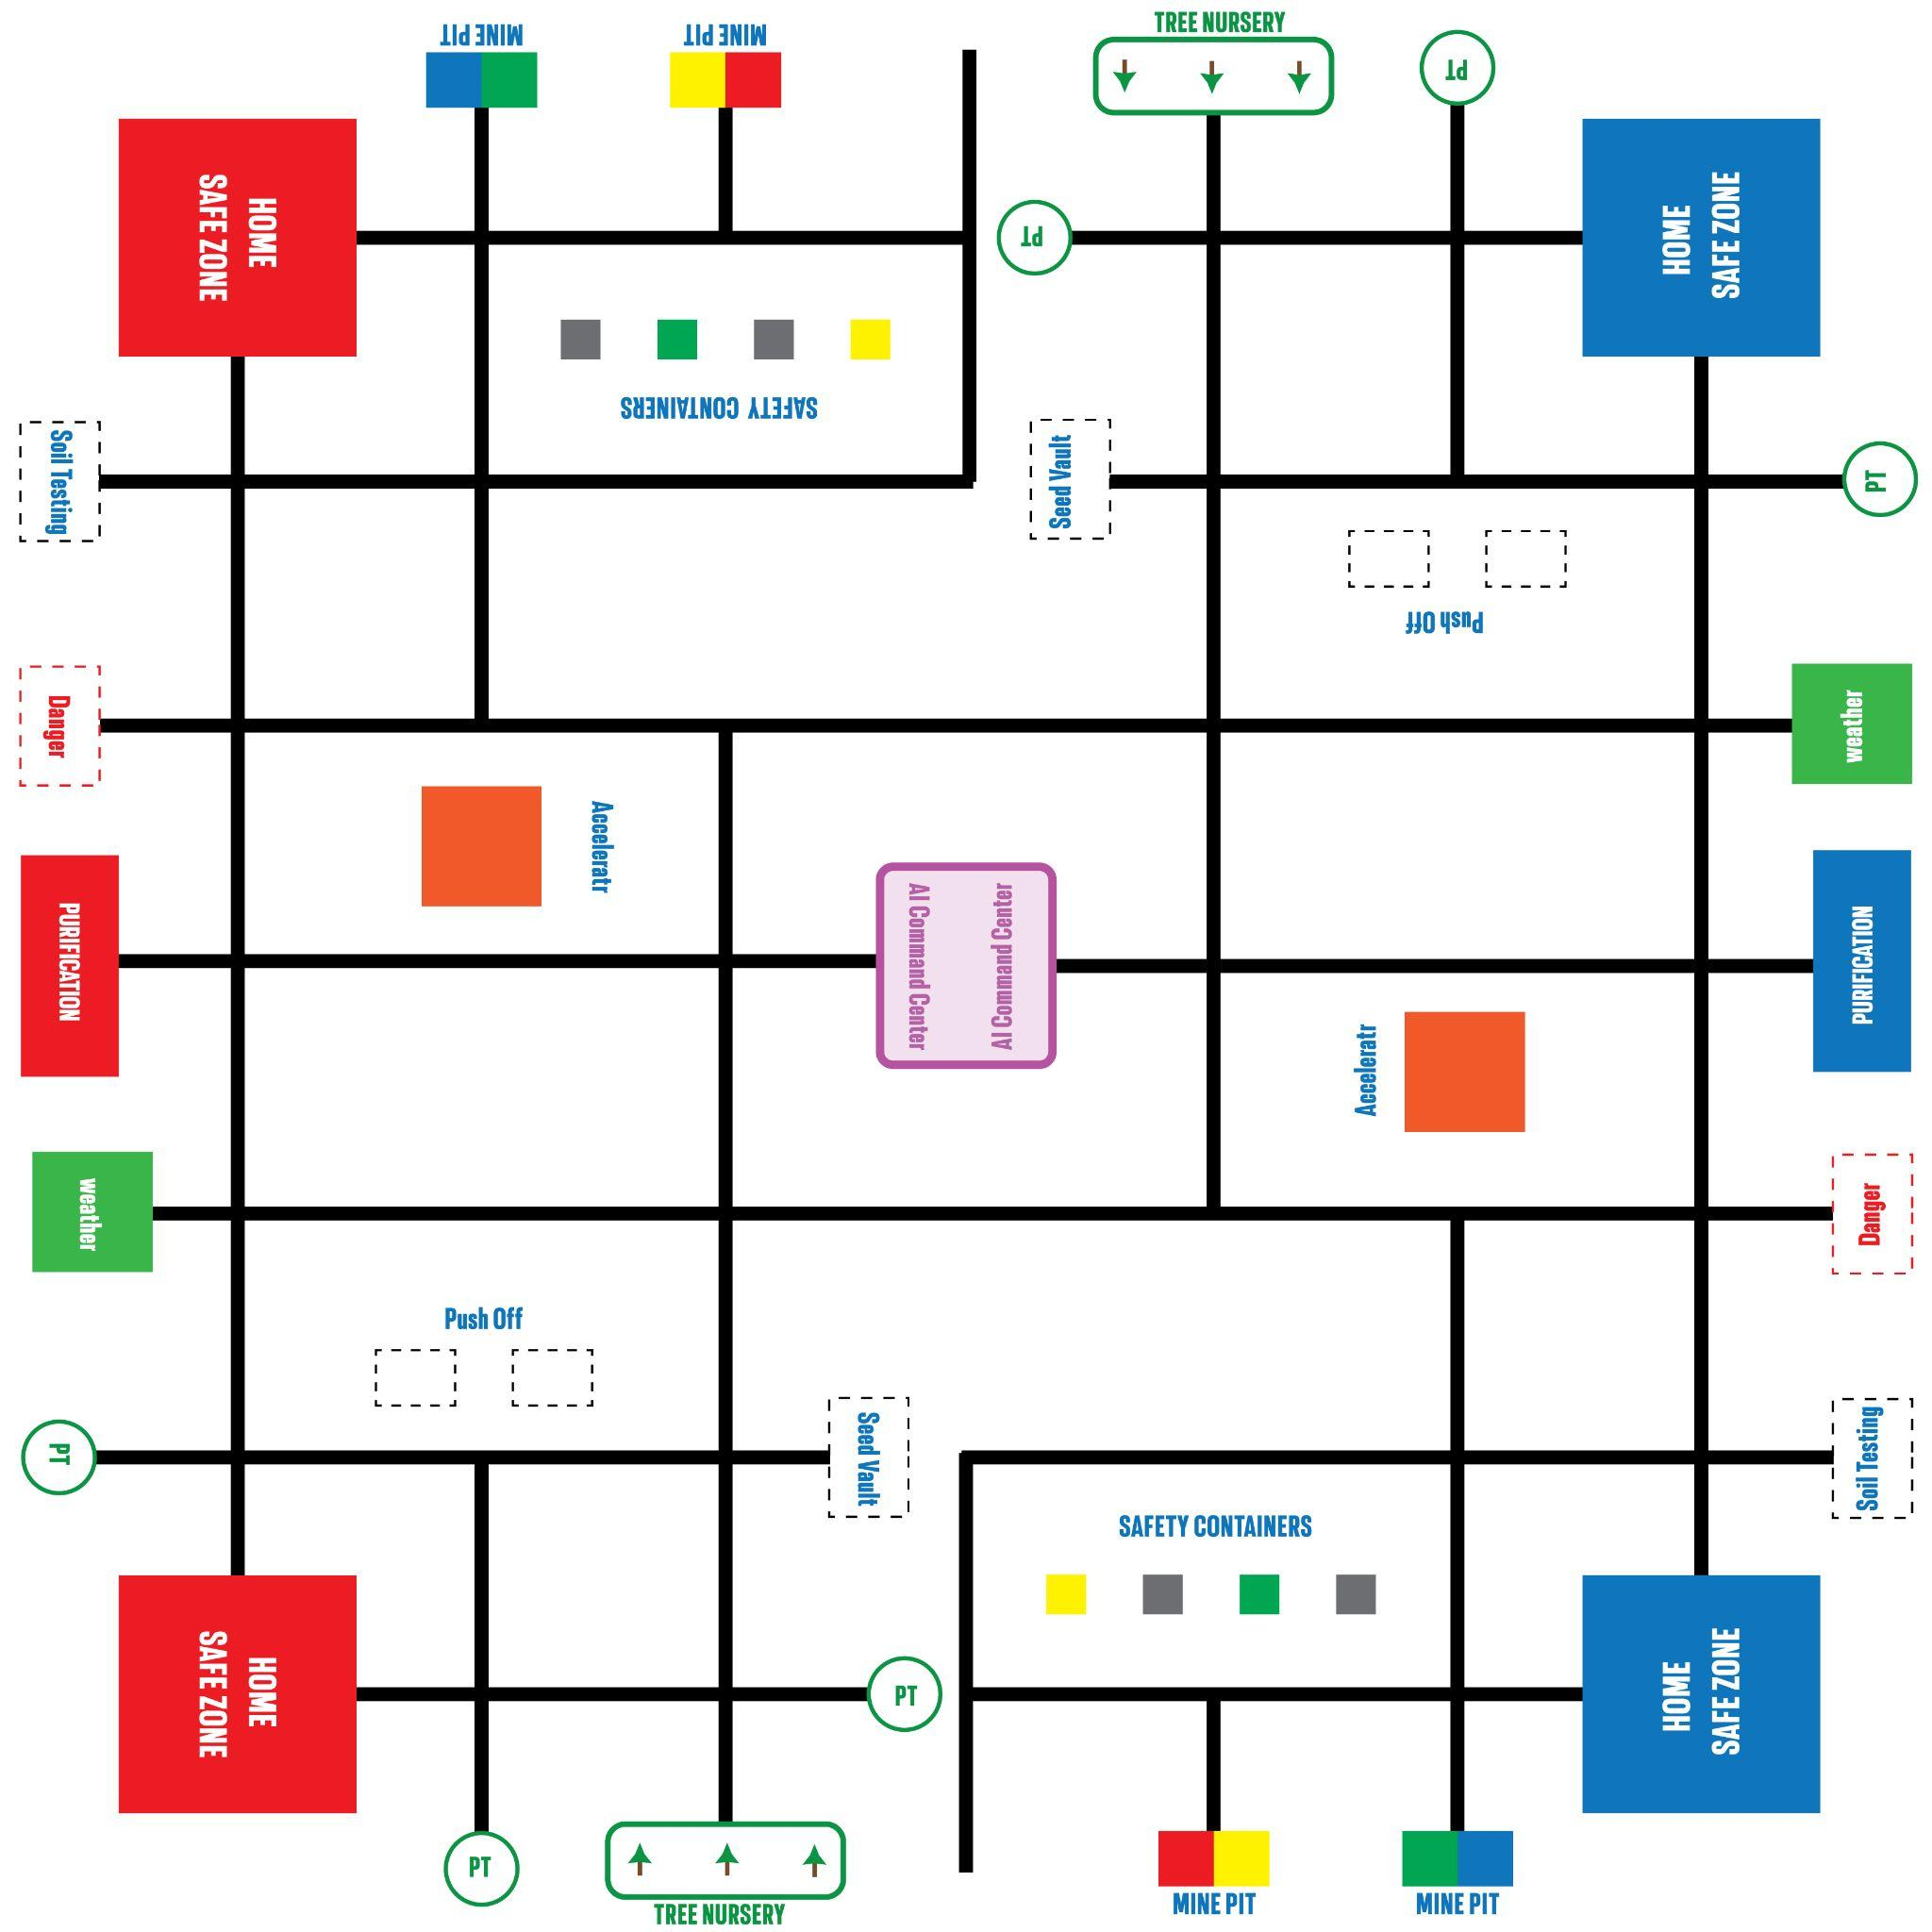

1.1 Match Format
Parameter | Value
Match Duration | 3 minutes total
Autonomous Period | 2 minutes (robots in own quadrant)
Manual Control Period | 1 minute (full field opens)
Endgame | Last 30 seconds of manual
Alliance Format | 2v2 (Red vs Blue)
Robots per Alliance | 2 (each in own quadrant)
Total Missions | 10 (4 per robot + 2 shared center)
Field Size | 96 × 96 inches (2438 × 2438mm)
Robot Platform | XploreBot
Robot Start Size | 30 × 30 × 30 cm max

1.2 The Quadrant System
The field is divided into 4 quadrants. Each robot gets its own quadrant with its own Home Base and missions. During the 2-minute autonomous period, all 4 robots work independently in their own quadrants — no collision risk. During the 1-minute manual period, the field opens, and alliance partners can cross quadrants and access the shared center.
Quadrant | Assignment
Top-Left | Red Robot 1 — Mine Safety + Soil + Wildlife + Accelerator
Top-Right | Blue Robot 1 — Mine Safety + Soil + Wildlife + Accelerator
Bottom-Left | Red Robot 2 — Reforestation + Weather + Seeds + Galamsey
Bottom-Right | Blue Robot 2 — Reforestation + Weather + Seeds + Galamsey
Center | Shared — AI Command Center + Water Purification (manual only)
Alliance partners are on the same side (adjacent quadrants). Scoring: R1 + R2 + center = Red Alliance total.

1.3 Track System
The field uses a hybrid track layout: main trunk lines with numbered branches and cross-links. Primary routes are solid black lines (20mm wide). Cross-links are dashed lines for alternate return paths. Primary junctions are filled green circles. Cross-link junctions are hollow green circles.

1.4 Challenge Narrative
Illegal mining has scarred Ghana’s landscape. Open pits endanger communities, soil is contaminated, wildlife is displaced, forests are destroyed, weather systems are down, and seeds of native plants are at risk. An AI-powered command center must be activated to coordinate the recovery. Two robots per alliance tackle different aspects of the crisis independently during autonomous, then come together during manual to complete the command center and purify contaminated water.

2. Robot 1 Missions — Mine & Wildlife Recovery
Robot 1 operates in the top quadrant. These missions focus on mine safety, soil testing, wildlife rescue, and activating the alliance’s Resilience Accelerator.

M1. Mine Pit Safety
Illegal mining has left dangerous open pits. Robots pick up color-coded safety containers from a track line and deliver each to its matching colored pit.
How It Works
Four safety containers (color-coded) are placed along a horizontal track line in the quadrant. Four matching mine pits are located at the top edge. The robot navigates to a container, picks it up, then follows the track to the matching pit. Placing a container in the wrong pit incurs a penalty.
Scoring
Action | Points
Correct container in matching pit (Autonomous) | 40
Correct container in matching pit (Manual) | 10
Wrong color container in pit | -15 penalty
All 4 pits correctly secured | +30 completion bonus
Field Elements
Element | Specification
Mine Pits | 4 recessed zones at top edge of quadrant (color-coded)
Safety Containers | 4 cubes (50mm), spaced along horizontal track line

M2. Soil Testing Station
Before land can be replanted, soil contamination must be assessed. The robot pushes a lever on the soil testing station to flip it and reveal the soil sample result.
Scoring
Action | Points
Lever fully flipped / latched (Autonomous) | 30
Lever fully flipped / latched (Manual) | 10
Field Elements
Element | Specification
Soil Testing Station | Hinged lever mechanism on track line, side edge of quadrant
• No-equipment constraint: robot cannot be touching the station at match end to score.

M3. Wildlife Rescue
Environmental damage has displaced wildlife into a danger zone. The robot picks up an animal figure and delivers it safely back to the Home Base (which serves as the wildlife sanctuary).
Scoring
Action | Points
Animal delivered to Home Base (Autonomous) | 35
Animal delivered to Home Base (Manual) | 10
Field Elements
Element | Specification
Animal Figure | 1 per quadrant, in marked Danger Zone on track line
Sanctuary | Home Base — animal must be fully inside Home to score

M4. Resilience Accelerator
Each alliance has its own Resilience Accelerator button in their Robot 1 quadrant. When activated, it doubles the alliance’s AI Command Center scoring for the remainder of the match.
Scoring
Action | Points
Accelerator activated | 0 (enables 2× M9 Command Center scoring)
Rules
• Each alliance has its own Accelerator — not shared between alliances
• Activation window: between 1:45 and 1:40 of the Autonomous period
• Robot must press and hold for approximately 2 seconds
• Once activated, doubles all AI Command Center scoring for that alliance

3. Robot 2 Missions — Land & Climate Recovery
Robot 2 operates in the bottom quadrant. These missions focus on reforestation, weather monitoring, seed preservation, and clearing illegal mining equipment.

M5. Reforestation
Degraded mining land must be replanted. The robot collects tree seedlings from the Tree Nursery and plants them in 3 separate planting depots.
Scoring
Action | Points
Tree planted in depot (Autonomous) | 30
Tree planted in depot (Manual) | 10
All 3 trees planted | +25 completion bonus
Field Elements
Element | Specification
Tree Seedlings | 3 per quadrant, arranged in line at Tree Nursery
Planting Depots | 3 separate depot locations, 1 planting hole each
• Trees must be placed upright in the hole to score.
• Robots may carry only 1 tree at a time.

M6. Weather Station Deployment
Climate monitoring systems are offline. The robot pushes a weather mast from horizontal to vertical until it latches in place.
Scoring
Action | Points
Mast raised and latched upright (Autonomous) | 30
Mast raised and latched upright (Manual) | 10
Field Elements
Element | Specification
Weather Station | Platform with hinged mast, on track line at side edge
Mast | Starts horizontal, latch holds vertical when raised
• No-equipment constraint: robot cannot be touching the station at match end.

M7. Seed Bank Collection (Manual Only)
Native plant seeds must be preserved. The robot collects seed containers from track positions and delivers them to the Home Base for safekeeping.
Scoring
Action | Points
Each seed container delivered to Home Base(Autonomus) | 25
Each seed container delivered to Home Base( Manual) | 10
All 3 seed containers delivered | +20 completion bonus
Field Elements
Element | Specification
Seed Containers | 3 per quadrant, small cubes on track lines
Delivery | Home Base — seeds must be inside Home to score

M8. Galamsey Equipment Removal
Illegal mining equipment must be cleared. The robot pushes equipment blocks completely off the field edge.
Scoring
Action | Points
Equipment pushed off field (Autonomous) | 30
Equipment pushed off field (Manual) | 10
Field Elements
Element | Specification
Equipment Blocks | 2 per quadrant, shown as dashed outlines on track positions
Push-off Edge | Marked edge of quadrant
• Blocks must be completely off the field surface to score.

4. Shared Center Missions (Manual Only)
The center of the field is shared between all alliances. These missions can only be attempted during the 1-minute manual period.

M9. AI Command Center
An AI-powered command center sits at the center of the field. Teams must deliver a Data Module, press the Broadcast Button, and raise the Antenna.
Scoring
Action | Standard | After Accelerator
Data Module to Upper Slot (120mm) | 30 | 60
Data Module to Lower Slot (40mm) | 10 | 20
Broadcast Button pressed | 15 | 30
First alliance to complete full sequence | +25 | +25
Field Elements
Element | Specification
Command Center | Central structure at field center, shared
Upper Slot | 60 × 60mm at 120mm height
Lower Slot | 60 × 60mm at 40mm height
Antenna | Hinged arm, starts horizontal
Broadcast Button | Spring-loaded, on platform
Data Module | 50mm cube, 1 per alliance, starts at Home Base
• Broadcast Button can only be pressed after a Data Module is inserted.
• Data Module starts at the alliance’s Home Base. Either Robot 1 or Robot 2 may carry and deliver it — the team decides their own strategy.

M10. Water Purification (Manual Only)
Contaminated water balls are scattered across the field. Robots collect as many as possible and deliver them to the Purification Station, which has an Upper Chamber (harder, more points) and a Lower Chamber (easier, fewer points).
Scoring
Action | Points
Water ball to Chamber | 5
Field Elements
Element | Specification
Water Balls | Multiple, scattered across the field
Purification Station | 1 per alliance, at side edge of field
Lower Chamber | Opening at 40mm height
• This mission is MANUAL ONLY.
• Robots may carry any number of water balls they want.
• Each alliance has its own Purification Station on their side.
5. Game Features

5.1 Precision Tokens
Each alliance starts with 7 Precision Tokens worth 15 points each (105 total). Each time a team member touches their robot outside the Home Base, one token is removed. Tokens remaining at match end are added to the score. Precision Token stations (PT) are located at various positions around the field edge.

5.2 Innovation Point
To earn the Innovation Point, the alliance must autonomously deliver a Data Module to the Upper Slot of the AI Command Center during the 2-minute autonomous period. Either Robot 1 or Robot 2 may attempt this. The Data Module starts at Home Base, so the robot must pick it up and navigate to center autonomously. This is tracked separately in rankings and serves as the first tiebreaker.
Action | Points
Data Module to the Upper Slot | 100

5.3 Emergency Evacuation (Endgame)
When 30 seconds remain, an audible signal sounds. Robots may return to their own Home Base.
Action | Points
1 robot in its Home Base at match end | 10
Both robots in their Home Bases at match end | 35

5.4 Surprise Rule
A single rule modification is revealed at the Opening Ceremony. Teams get 60 minutes of practice time to adapt before matches begin.

6. General Rules

6.1 Match Phases
1. Setup (30 sec): Place robots in assigned quadrant Home Base.
2. Autonomous (2 min): Robots in own quadrant only. Line-following, no remote control.
3. Manual (1 min): Full field opens. Remote control. Center missions accessible. Accelerator window: 0:45 to 0:15.
4. Endgame (last 30 sec): Warning signal. Evacuation scoring available.

6.2 Autonomous Rules
• Robots must stay in their assigned quadrant during autonomous.
• Crossing the quadrant boundary during autonomous: 10-point penalty.
• Autonomous scoring earns higher points than manual (see each mission).

6.3 Penalties
• Touch robot outside Home Base: lose 1 Precision Token
• Cross quadrant boundary during autonomous: 10-point penalty
• Damage field or opponent robot: disqualification
• Wrong color container in pit: -15 points

6.4 Tiebreaker Order
1. Higher Autonomous Score
2. Fewer Penalties
3. Innovation Point (autonomous Network Module to center)
4. Replay

7. Tournament Format

7.1 Preliminary Matches (Ranking Stage)
All preliminary matches are ranking-based. Every team plays 3 preliminary matches. The scores from all 3 matches are added together. Teams are ranked by their total combined score.
Ranking is based purely on the total points earned from completing missions across all preliminary matches. There are no win points — only total score matters.

7.2 Qualification to Knockout
The number of teams qualifying to the knockout stage depends on the total number of teams in the league:
Number of Teams in League | Teams Qualifying to Knockout
More than 32 teams | Top 32 qualify
17 to 32 teams | Top 16 qualify
9 to 16 teams | Top 8 qualify
8 or fewer teams | All teams may qualify
Only the highest-ranked teams from the preliminary stage advance. All other teams are eliminated.

7.3 Knockout Stage (Direct Elimination)
The knockout stage is direct elimination. Win and advance. Lose and you are out.
In the knockout stage, each match is independent. The only thing that matters is whether you win your specific match — not your score compared to other matches happening elsewhere.
Example: If Team A beats Team B 100–50, and Team C beats Team D 15–10, both Team A and Team C advance. Team B and Team D are eliminated. We do NOT compare Team B’s 50 points to Team C’s 15 points — each match is its own contest.
If a match results in only one team being present (opponent no-show or disqualification), that one team still plays solo and advances to the next stage.

7.4 Knockout Tiebreaker
If a knockout match ends in a tie, the following sequence applies:
1. Autonomous Score: Alliance with higher autonomous period score wins
2. Replay: If still tied, a 2-minute replay match is conducted (teams get 5 minutes to prepare)

8. Match Procedures

8.1 Robot Malfunction
• If a robot is non-functional before the match: the team still reports to the field. The match proceeds with the alliance partner competing alone. Not grounds for replay unless caused by field malfunction.
• If a robot malfunctions during the match: no timeout or repair allowed. Points earned before malfunction still count.
• If both alliance robots are non-functional: opposing alliance plays normally. Non-functional alliance receives 0 points.

8.2 Alliance Partner No-Show
• A 2-minute grace period is provided after the match is called
• After grace period: the team is declared a no-show and receives 0 points
• The present team plays alone; their score counts normally
• Repeated no-shows (3 or more) may result in disqualification

8.3 Field Malfunction
• Head Referee immediately stops the match
• If less than 1 minute elapsed: match replayed from beginning
• If more than 1 minute elapsed: match continues from point of stoppage
• All teams get 5 minutes to reset robots

8.4 Schedule
• Matches scheduled with 5-minute intervals (3-min match + 2-min transition)
• Teams must queue 10 minutes before their scheduled match
• Buffer time built in every 10 matches
• Competition Director has authority to adjust schedules as needed

9. Coaches / Adult General Rules
When in doubt, remember: “Student Led, Student Success”

9.1 Focus on Learning Over Winning
Emphasize the importance of learning and personal growth over the desire to win. This helps students appreciate the broader skills they develop through the competition.

9.2 Respect Student Centeredness
Students must be the only ones designing, building, programming, and troubleshooting their robots. This encourages critical thinking, problem-solving, and teamwork skills.

9.3 Provide Guidance, Not Answers
Provide guidance through leading questions and guided discussions rather than providing direct answers or solutions. This helps students develop independence and confidence.

9.4 Maintain a Positive Environment
Create a supportive and encouraging atmosphere. Avoid negative comments or criticism. A positive environment boosts student morale and encourages a growth mindset.

9.5 Encourage Student Communication
Students should be the only ones who communicate directly with judges, referees, and members of other teams. This gives students opportunities to practice presentation, problem-solving, and negotiation skills.

9.6 Stay Behind the Scenes
Adults should stay in the background during active problem-solving and match play. When students are the primary participants and leaders, all teams are on a level playing field.

9.7 Respect All Participants
Treat all students, mentors, volunteers, and other event attendees with respect and courtesy. Respectful behavior promotes a fair and enjoyable experience for everyone.

10. Complete Scoring Summary
Robot 1 (Top Quadrant)
Mission | Autonomous | Manual
M1: Container to correct pit | 40 each | 10 each
M1: All 4 pits secured | +30 | +20
M1: Wrong color penalty | -15 | -15
M2: Soil testing lever flipped | 30 | 10
M3: Animal to Home Base | 35 | 10
M4: Accelerator activated | — | 0 (enables 2× M9)

Robot 2 (Bottom Quadrant)
Mission | Autonomous | Manual
M5: Tree planted in depot | 30 each | 10 each
M5: All 3 trees planted | +25 | +20
M6: Weather mast raised | 30 | 10
M7: Seed to Home Base | — | 15 each
M7: All 3 seeds delivered | — | +20
M8: Equipment off field | 25 each | 15 each

Shared Center + General
Action | Points
M9: Data Module Upper / Lower Slot | 30 / 20 (60 / 40 after Accelerator)
M9: Broadcast Button | 15
M9: Antenna raised | 20
M9: First full sequence | +25
M10: Water ball Upper / Lower Chamber | 20 / 10
Endgame: 1 robot home / Both home | 10 / 35
Each Precision Token remaining (7 max) | 15
Maximum token bonus | 105

END OF STARS LEAGUE GAME MANUAL v3.0
Ghana Robotics Competition 2026 — Powered by Firefly IO

