

GHANA ROBOTICS COMPETITION 2026
TECHS LEAGUE
GAME MANUAL

AgriTech Revolution
Building Ghana’s Smart Agriculture Economy

For Grades 4 to 9 (Primary and Junior High School)
8 Missions • 4-Quadrant Field • 2v2 Alliance Play
1 Minute Autonomous + 2 Minutes Manual

Theme: AI & Robotics for Sustainable Africa
Focus: Job Creation through Technology & Agriculture
Field: 70 × 70 inches (1780 × 1780mm)

Version 1.0 — April 2026
Prepared by Firefly IO — grc@fireflyio.com

1. Competition Overview

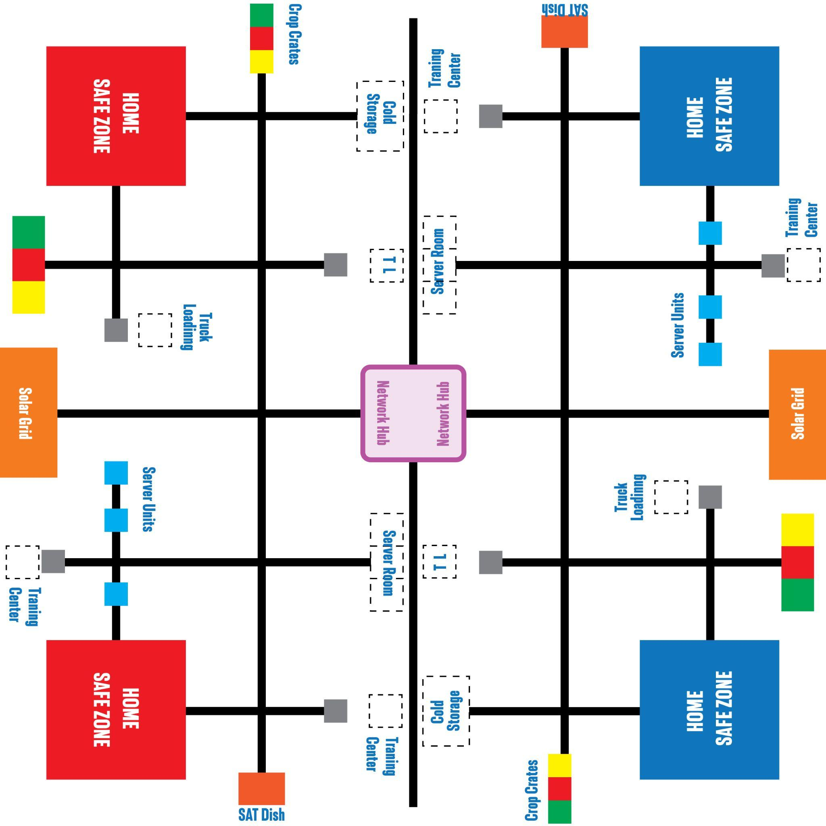

1.1 Theme: AgriTech Revolution
Agriculture employs nearly half of Ghana’s workforce, yet the sector faces challenges: post-harvest losses, limited cold storage, poor market connectivity, and lack of digital infrastructure. At the same time, Ghana’s tech sector is booming — creating new jobs in software, data, networking, and digital services.
In the Techs League, students build the future by combining both sectors. Robot 1 builds a smart farm — harvesting crops, activating cold storage, and loading delivery trucks. Robot 2 builds a tech hub — setting up servers, deploying satellite connectivity, and delivering workstations for training. The shared center connects them: solar power runs both, and a digital network links farm data to the tech hub.
Every mission represents a real job: farmer, factory worker, truck driver, IT technician, satellite engineer, trainer, solar installer, network engineer. Students aren’t just competing — they’re building Ghana’s economy.

1.2 Match Format
Parameter | Value
Match Duration | 3 minutes total
Autonomous Period | 1 minute (robots in own quadrant)
Manual Control Period | 2 minutes (full field opens)
Endgame | Last 30 seconds of manual
Alliance Format | 2v2 (Red vs Blue)
Robots per Alliance | 2 (each in own quadrant)
Total Missions | 8 (3 per robot + 2 shared center)
Field Size | 70 × 70 inches (1780 × 1780mm)
Robot Platform | XploreBot
Robot Start Size | 30 × 30 × 30 cm max

1.3 The Quadrant System
The field is divided into 4 quadrants. Each robot gets its own quadrant with its own Home Base and missions. During the 1-minute autonomous period, all 4 robots work independently — no collision risk. During the 2-minute manual period, the field opens and partners can cross quadrants and access the shared center.
Quadrant | Assignment
Top-Left | Red Robot 1 — The Smart Farm (3 missions)
Top-Right | Blue Robot 1 — The Smart Farm (3 missions)
Bottom-Left | Red Robot 2 — The Tech Hub (3 missions)
Bottom-Right | Blue Robot 2 — The Tech Hub (3 missions)
Center | Shared — Solar Power Grid + Network Connection (manual only)
Alliance partners are on the same side (adjacent quadrants). Scoring: R1 + R2 + center = Red Alliance total.

1.4 Track System
The field uses a hybrid track layout: main trunk lines with numbered branches and cross-links. Primary routes are solid black lines (20mm wide). Cross-links are dashed lines for alternate paths. Primary junctions are filled green circles. Cross-link junctions are hollow green circles. The robot navigates by following lines and counting junctions.

2. Robot 1 Missions — The Smart Farm
Robot 1 operates in the top quadrant. These missions represent the agricultural production chain: harvest, store, and ship.

M1. Crop Harvest
The farm’s crops are ready for harvest. The robot picks up crop crates from the farm field and delivers them to the Processing Factory for packaging.
How It Works
Three crop crates are placed along track lines in the farm area of the quadrant. The Processing Factory is located at a different position in the quadrant. The robot navigates to each crate, picks it up, and delivers it to the factory.
Scoring
Action | Points
Crop crate delivered to Factory (Autonomous) | 25
Crop crate delivered to Factory (Manual) | 10
All 3 crates delivered | +20 completion bonus
Field Elements
Element | Specification
Crop Crates | 3 per quadrant, 50mm cubes, on track lines
Processing Factory | Marked delivery zone in quadrant
• Robots may carry only 1 crate at a time.
• Crate must be fully inside the Factory zone to score.

M2. Cold Storage Activation
Post-harvest losses cost Ghana millions annually. The robot activates the cold storage unit by pushing a lever to switch it on, preserving the harvested crops and reducing waste.
Scoring
Action | Points
Cold storage lever flipped / latched (Autonomous) | 30
Cold storage lever flipped / latched (Manual) | 10
Field Elements
Element | Specification
Cold Storage Unit | Platform with hinged lever mechanism, on track line
• No-equipment constraint: robot cannot be touching the unit at match end to score.
• Lever must be fully flipped and latched.

M3. Delivery Truck Loading
Processed products need to reach the market. The robot picks up packaged product boxes from the factory output and delivers them to the Truck Loading Zone at the field edge — representing the logistics and distribution jobs.
Scoring
Action | Points
Product box delivered to Loading Zone (Autonomous) | 25
Product box delivered to Loading Zone (Manual) | 10
Field Elements
Element | Specification
Product Boxes | 2 per quadrant, 50mm cubes, near factory area
Truck Loading Zone | Marked zone at edge of quadrant
• Boxes must be fully inside the Loading Zone to score.

3. Robot 2 Missions — The Tech Hub
Robot 2 operates in the bottom quadrant. These missions represent building Ghana’s digital infrastructure: data centers, connectivity, and training.

M4. Server Rack Setup
Every tech hub needs computing power. The robot picks up server units from storage and delivers them to the Server Room to set up the data center.
Scoring
Action | Points
Server unit delivered to Server Room (Autonomous) | 25
Server unit delivered to Server Room (Manual) | 10
All 3 servers delivered | +20 completion bonus
Field Elements
Element | Specification
Server Units | 3 per quadrant, 50mm cubes, on track lines
Server Room | Marked delivery zone in quadrant
• Robots may carry only 1 server at a time.

M5. Satellite Dish Deployment
The tech hub needs internet connectivity. The robot pushes a satellite dish from its flat transport position to upright until it latches — establishing the communication link.
Scoring
Action | Points
Satellite dish raised and latched (Autonomous) | 30
Satellite dish raised and latched (Manual) | 10
Field Elements
Element | Specification
Satellite Dish | Hinged mechanism on platform, on track line at side edge
• No-equipment constraint: robot cannot be touching the dish at match end.
• Dish must be within 10° of vertical and latched.

M6. Workstation Delivery
Digital skills training creates jobs. The robot picks up workstation units and delivers them to the Training Center — representing the computers where community members learn coding, design, and digital skills.
Scoring
Action | Points
Workstation delivered to Training Center (Autonomous) | 25
Workstation delivered to Training Center (Manual) | 10
Field Elements
Element | Specification
Workstation Units | 2 per quadrant, 50mm cubes, on track lines
Training Center | Marked delivery zone in quadrant

4. Shared Center Missions (Manual Only)
The center connects the Smart Farm to the Tech Hub. These missions power everything and create the digital link between agriculture and technology.

M7. Solar Power Grid (Manual Only)
Both the smart farm and the tech hub need electricity. Solar panel tiles are scattered near track lines across the field. Robots collect them and place them on the central Solar Station to generate power.
Scoring
Action | Points
Solar tile placed on Upper Platform | 20
Solar tile placed on Lower Platform | 10
Field Elements
Element | Specification
Solar Tiles | Multiple, scattered near track lines across field
Solar Station | Central structure with upper and lower platforms
Upper Platform | Higher placement area (harder, more points)
Lower Platform | Lower placement area (easier, fewer points)
• This mission is MANUAL ONLY.
• Each alliance has its own side of the Solar Station.
• Robots may carry a maximum of 2 tiles at once.

M8. Network Connection (Manual Only)
The final step: connecting the smart farm’s data systems to the tech hub’s servers. A Network Module must be delivered from Home Base to the central Connection Hub, the activation button pressed, and the antenna mast raised.
Scoring
Action | Points
Network Module delivered to Connection Hub | 25
Activation Button pressed | 15
First alliance to complete full connection | +25 race bonus
First alliance to complete full connection Autonomous | +50 race bonus
Field Elements
Element | Specification
Network Module | 50mm cube, 1 per alliance, starts at Home Base
Connection Hub | Central structure at field center
Activation Button | Spring-loaded button on hub
Antenna Mast | Hinged arm, starts horizontal
• This mission is MANUAL ONLY.
• Network Module starts at Home Base. Either Robot 1 or Robot 2 may carry and deliver it — the team decides.
• Button can only be pressed after Module is delivered.
• Antenna must be within 10° of vertical to score.

5. Game Features

5.1 Precision Tokens
Each alliance starts with 7 Precision Tokens worth 15 points each (105 total). Each time a team member touches their robot outside the Home Base, one token is removed by the referee. Tokens remaining at match end are added to the alliance score.
Tokens are removed for: touching the robot outside Home Base, reaching across the field boundary, or interfering with opposing alliance’s field elements.

5.2 Innovation Point
To earn the Innovation Point, the alliance must autonomously deliver the Network Module from Home Base to the Connection Hub at field center during the 1-minute autonomous period. Either Robot 1 or Robot 2 may attempt this. This is tracked separately in rankings and serves as the first tiebreaker.

5.3 Emergency Evacuation (Endgame)
When 30 seconds remain, an audible signal sounds. Robots may return to their own Home Base (which doubles as the Safe Zone).
Action | Points
1 robot in its Home Base at match end | 10
Both robots in their Home Bases at match end | 35
Each robot returns to its OWN quadrant Home Base. The non-linear bonus (35 vs 20) rewards both robots successfully evacuating.

5.4 Surprise Rule
A single rule modification is revealed at the Opening Ceremony on competition day. Teams get 60 minutes of practice time to adapt before matches begin.

6. General Rules

6.1 Robot Specifications
Requirement | Specification
Platform | XploreBot (Firefly IO)
Maximum Starting Size | 30 × 30 × 30 cm
Programming | Xplore IDE
Navigation | Line-following sensors (no encoders)
Autonomous Method | Follow track lines + count junctions
Control (Manual) | Remote control via approved controller

6.2 Match Phases
1. Setup (30 sec): Place robots in assigned quadrant Home Base.
2. Autonomous (1 min): Robots in own quadrant only. Pre-programmed code, no remote control.
3. Manual (2 min): Full field opens. Remote control. Center missions accessible.
4. Endgame (last 30 sec of manual): Warning signal. Evacuation scoring available.

6.3 Autonomous Rules
• Robots must stay in their assigned quadrant during autonomous.
• Crossing the quadrant boundary during autonomous: 10-point penalty.
• Exception: A robot that autonomously delivers the Network Module to center earns the Innovation Point.
• Autonomous scoring earns higher points than manual (see each mission).

6.4 Alliance Structure
Each alliance consists of 2 teams. Robot 1 handles The Smart Farm (top quadrant). Robot 2 handles The Tech Hub (bottom quadrant). Teams are assigned to Robot 1 or Robot 2 before each match.

6.5 Penalties
• Touch robot outside Home Base: lose 1 Precision Token
• Cross quadrant boundary during autonomous: 10-point penalty
• Damage field or opponent robot: disqualification

6.6 Tiebreaker Order
1. Higher Autonomous Score
2. Fewer Penalties
3. Innovation Point (autonomous Network Module to center)
4. Replay

7. Tournament Format

7.1 Preliminary Matches (Ranking Stage)
All preliminary matches are ranking-based. Every team plays 3 preliminary matches. The scores from all 3 matches are added together. Teams are ranked by their total combined score.
Ranking is based purely on the total points earned from completing missions across all preliminary matches. There are no win points — only total score matters.

7.2 Qualification to Knockout
The number of teams qualifying to the knockout stage depends on the total number of teams in the league:
Number of Teams in League | Teams Qualifying to Knockout
More than 32 teams | Top 32 qualify
17 to 32 teams | Top 16 qualify
9 to 16 teams | Top 8 qualify
8 or fewer teams | All teams may qualify(Divisible by 4 Team)
Only the highest-ranked teams from the preliminary stage advance. All other teams are eliminated.

7.3 Knockout Stage (Direct Elimination)
The knockout stage is direct elimination. Win and advance. Lose and you are out.
In the knockout stage, each match is independent. The only thing that matters is whether you win your specific match — not your score compared to other matches happening elsewhere.
Example: If Team A beats Team B 100–50, and Team C beats Team D 15–10, both Team A and Team C advance. Team B and Team D are eliminated. We do NOT compare Team B’s 50 points to Team C’s 15 points — each match is its own contest.
If a match results in only one team being present (opponent no-show or disqualification), that one team still plays solo and advances to the next stage.

7.4 Knockout Tiebreaker
If a knockout match ends in a tie, the following sequence applies:
1. Autonomous Score: Alliance with higher autonomous period score wins
2. Replay: If still tied, a 2-minute replay match is conducted (teams get 5 minutes to prepare)

9. Match Procedures

9.1 Robot Malfunction
• If a robot is non-functional before the match: the team still reports to the field. The match proceeds with the alliance partner competing alone. No grounds for replay unless caused by field malfunction.
• If a robot malfunctions during the match: no timeout or repair allowed. Points earned before malfunction still count.
• If both alliance robots are non-functional: opposing alliance plays normally. Non-functional alliance receives 0 points.

9.2 Alliance Partner No-Show
• A 2-minute grace period is provided after the match is called
• After grace period: the team is declared a no-show and receives 0 points
• The present team plays alone; their score counts normally
• Repeated no-shows (3 or more) may result in disqualification

9.3 Field Malfunction
• Head Referee immediately stops the match
• If less than 1 minute elapsed: match replayed from beginning
• If more than 1 minute elapsed: match continues from point of stoppage
• All teams get 2 minutes to reset robots

9.4 Schedule
• Matches scheduled with 5-minute intervals (3-min match + 2-min transition)
• Teams must queue 10 minutes before their scheduled match
• Buffer time built in every 10 matches
• Competition Director has authority to adjust schedules as needed

10. Coaches / Adult General Rules
When in doubt, remember: “Student Led, Student Success”

10.1 Focus on Learning Over Winning
Emphasize the importance of learning and personal growth over the desire to win. This helps students appreciate the broader skills they develop through the competition.

10.2 Respect Student Centeredness
Students must be the only ones designing, building, programming, and troubleshooting their robots. This encourages critical thinking, problem-solving, and teamwork skills.

10.3 Provide Guidance, Not Answers
Provide guidance through leading questions and guided discussions rather than providing direct answers or solutions. This helps students develop independence and confidence.

10.4 Maintain a Positive Environment
Create a supportive and encouraging atmosphere. Avoid negative comments or criticism. A positive environment boosts student morale and encourages a growth mindset.

10.5 Encourage Student Communication
Students should be the only ones who communicate directly with judges, referees, and members of other teams. This gives students opportunities to practice presentation, problem-solving, and negotiation skills.

10.6 Stay Behind the Scenes
Adults should stay in the background during active problem-solving and match play. When students are the primary participants and leaders, all teams are on a level playing field.

10.7 Respect All Participants Judges
Treat all students, mentors, volunteers, and other event attendees with respect and courtesy. Respectful behavior promotes a fair and enjoyable experience for everyone.

7. Complete Scoring Summary
Robot 1 — The Smart Farm (Top Quadrant)
Mission | Autonomous | Manual
M1: Crop crate to Factory | 25 each | 15 each
M1: All 3 crates delivered | +20 | +20
M2: Cold storage lever flipped | 30 | 20
M3: Product box to Loading Zone | 25 each | 15 each

Robot 2 — The Tech Hub (Bottom Quadrant)
Mission | Autonomous | Manual
M4: Server unit to Server Room | 25 each | 15 each
M4: All 3 servers delivered | +20 | +20
M5: Satellite dish raised | 30 | 20
M6: Workstation to Training Center | 25 each | 15 each

Shared Center + General
Action | Points
M7: Solar tile on Upper Platform | 20
M7: Solar tile on Lower Platform | 10
M8: Network Module to Hub | 25
M8: Activation Button pressed | 15
M8: Antenna raised | 20
M8: First to complete full connection | +25
Endgame: 1 robot home | 10
Endgame: Both robots home | 35
Each Precision Token remaining (7 max) | 15
Maximum token bonus | 105

Every mission = a real job. Every point = a step toward Ghana’s future.

END OF TECHS LEAGUE GAME MANUAL v1.0
Ghana Robotics Competition 2026 — Powered by Firefly IO
grc@fireflyio.com — +233 54 452 5401

